DAY 2 LAB

- Mini-Max Algorithm
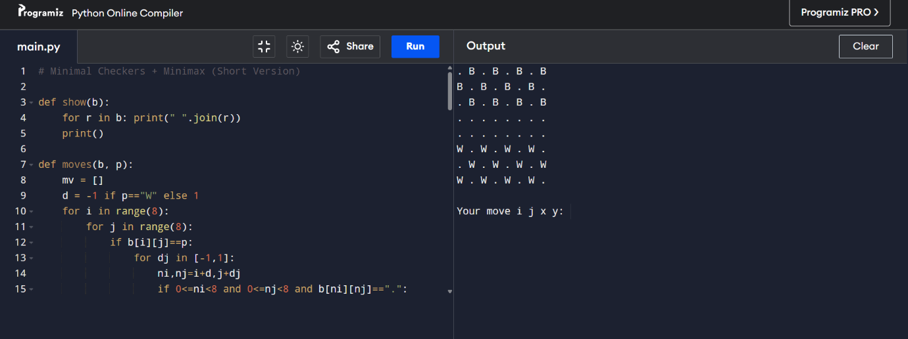

ALGORITHM:
- Represent the board as an 8×8 grid and define rules for legal moves (normal moves + jumps).
- Generate all possible moves for the current player by checking each piece and its allowed directions.
- Use Minimax with Alpha–Beta pruning to evaluate moves by exploring possible future board states.
- Choose the best move for the AI (maximizing score) and execute it on the board.
- Repeat until no moves are available and then declare winner based on remaining piece

- Tic-Tac-Toe
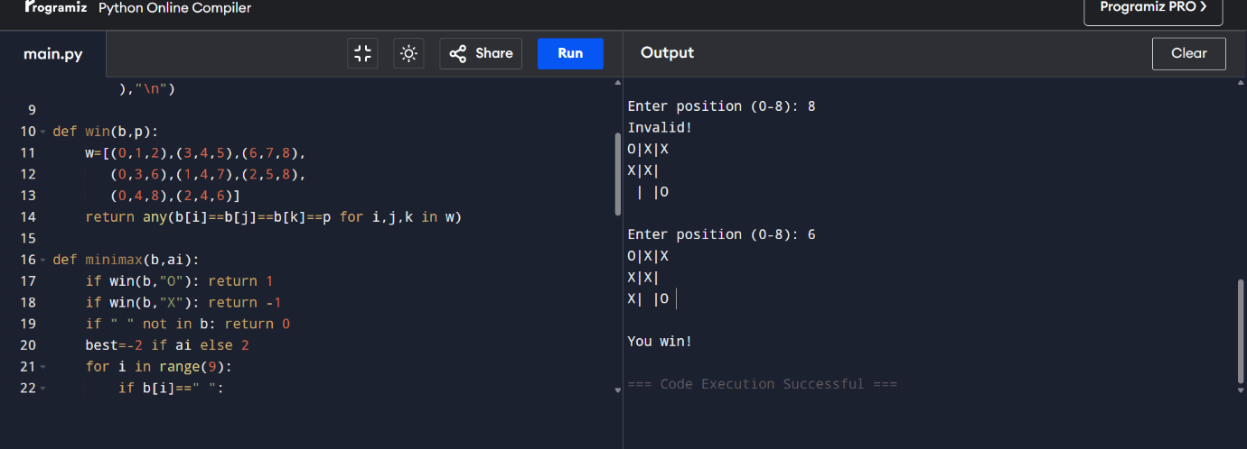

ALGORITHM:
- Initialize a 3×3 board with empty cells.
- Human enters a move; update board and print it.
- AI uses Minimax algorithm to evaluate all possible moves and select the one that leads to the best outcome.
- After every move, check for win or draw using all winning combinations.
- Continue alternating turns until X or O wins, or no spaces remain → draw.

- Vacuum Cleaner

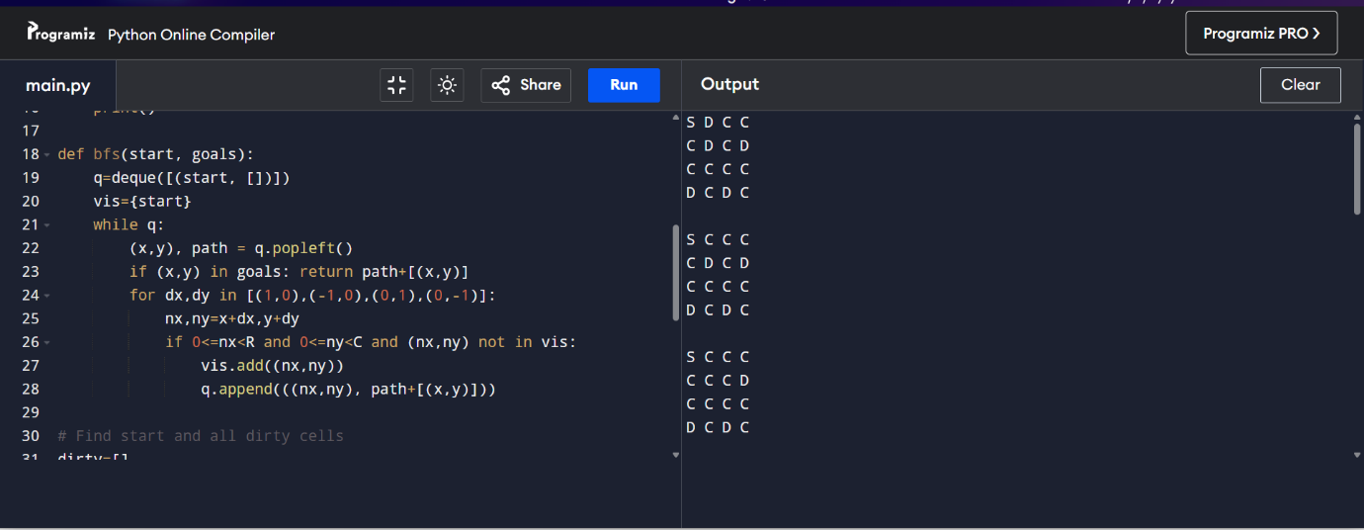

ALGORITHM:
- Represent the environment as a grid with clean and dirty cells and a starting position.
- Identify all dirty cells and locate the vacuum’s current position.
- Use BFS (Breadth-First Search) to find the shortest path to the nearest dirty cell.
- Move step-by-step along the path, cleaning the cell once the vacuum reaches it.
- Repeat BFS and cleaning until all dirty cells are cleaned, then stop.

- N QUEENS

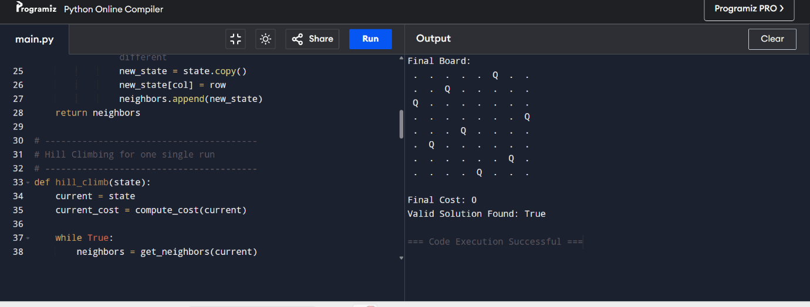
ALGORITHM:

- Start with a random state: place one queen in each column.
- Compute the cost as the number of attacking queen pairs.
- Generate all neighbors by moving each queen within its column.
- Move to the neighbor with the lowest cost if it improves the current cost.
- Stop when no better neighbor exists; use random restarts (optional) until cost = 0.

- Min-Max

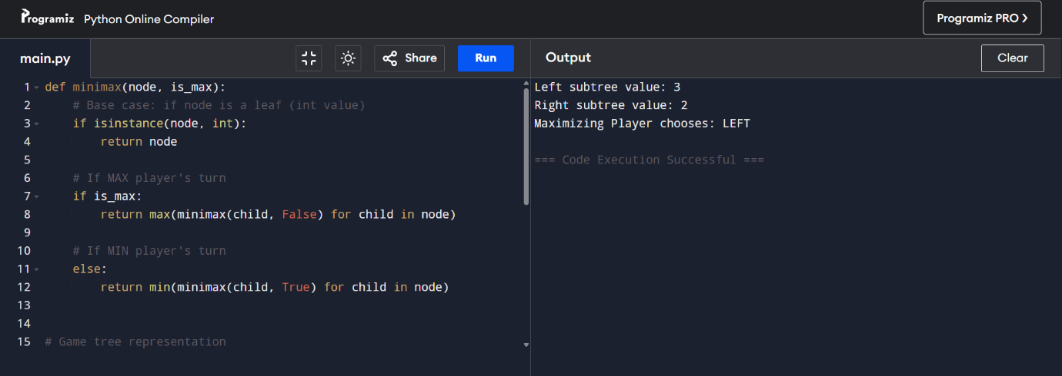

ALGORITHM:
- Start at the root (MAX); evaluate both left and right subtrees.
- At each MIN node, choose the minimum value among its leaf children.
- At each MAX node, choose the maximum value among its children’s evaluated values.
- Compare the evaluated values of the left MIN subtree and the right MIN subtree.
- Choose the branch that gives MAX the higher value (optimal move).

- A* Search

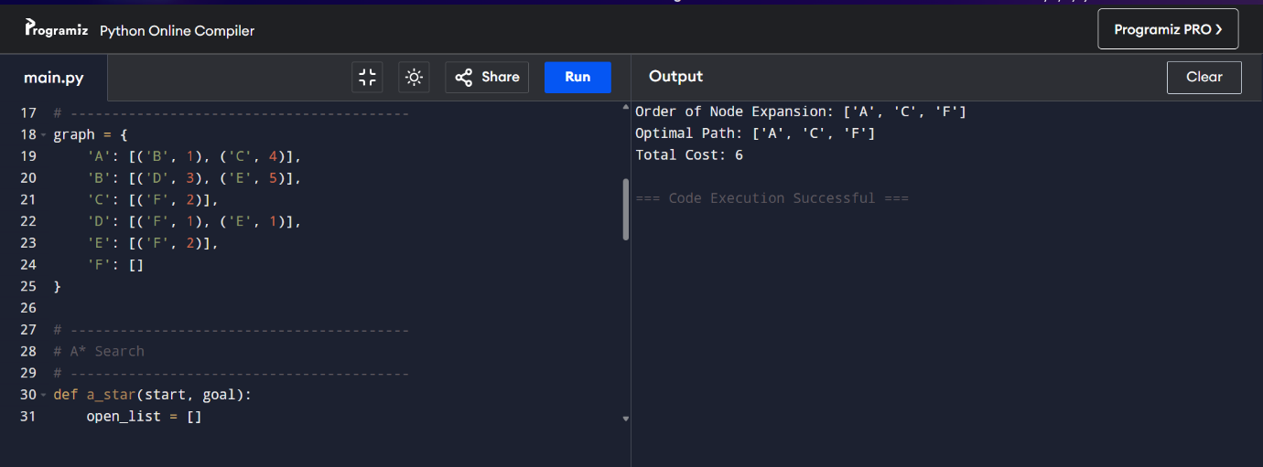

ALGORITHM:
- nitialize open_list with the start node and set its cost g = 0 and f = g + h.
- Repeatedly pick the node from open_list having the smallest f value.
- If it is the goal node, reconstruct and return the final optimal path.
- Otherwise, expand its neighbors, updating g (path cost) and f = g + h if a better path is found.
- Move expanded nodes to closed_list and continue until the goal is reached.

